PBL Phase 2 Report
End to End Pre Loan Default Assessment System
Project Id: AIML-2

Name: Rishith Arora
Class Roll no. : 25
University Roll no. : 2519150
Section : X

Name: Tarun Pratap Singh
Class Roll no. : 31
University Roll no. : 2519550
Section : X

Name: Priyanshu Bisht
Class Roll no. : 23
University Roll no. : 2519458
Section : X

Index

S.no. | Title | Page
1. | Problem Description  1.1. Problem Description  1.2 Flow Diagram | 3-4
2. | Modules for project implementation  2.1. Modules Used  2.2. Platform Used | 5-7
3. | Machine Learning Models used | 8
4. | Evaluation metrics used | 9
5. | Results and Visualizations | 10-11
6. | Conclusion and Future Scope | 12
7. | References | 12

1. Problem Description
The financial sector faces significant risks from 'credit risk,' where borrowers fail to repay loans, leading to substantial economic losses. This project aims to develop a predictive model that identifies potential 'loan defaulters' based on historical customer banking data. By leveraging classification algorithms, banks can automate the risk assessment process, ensuring more objective and data-driven lending decisions. In real life, this minimizes non-performing assets (NPAs) and helps maintain the stability of the banking ecosystem.
1.1. Dataset description
The dataset contains historical banking records including Age, Income, Loan Amount, Credit Score, Months Employed, and Loan Term. It includes categorical data like Education, Marital Status, and Loan Purpose.
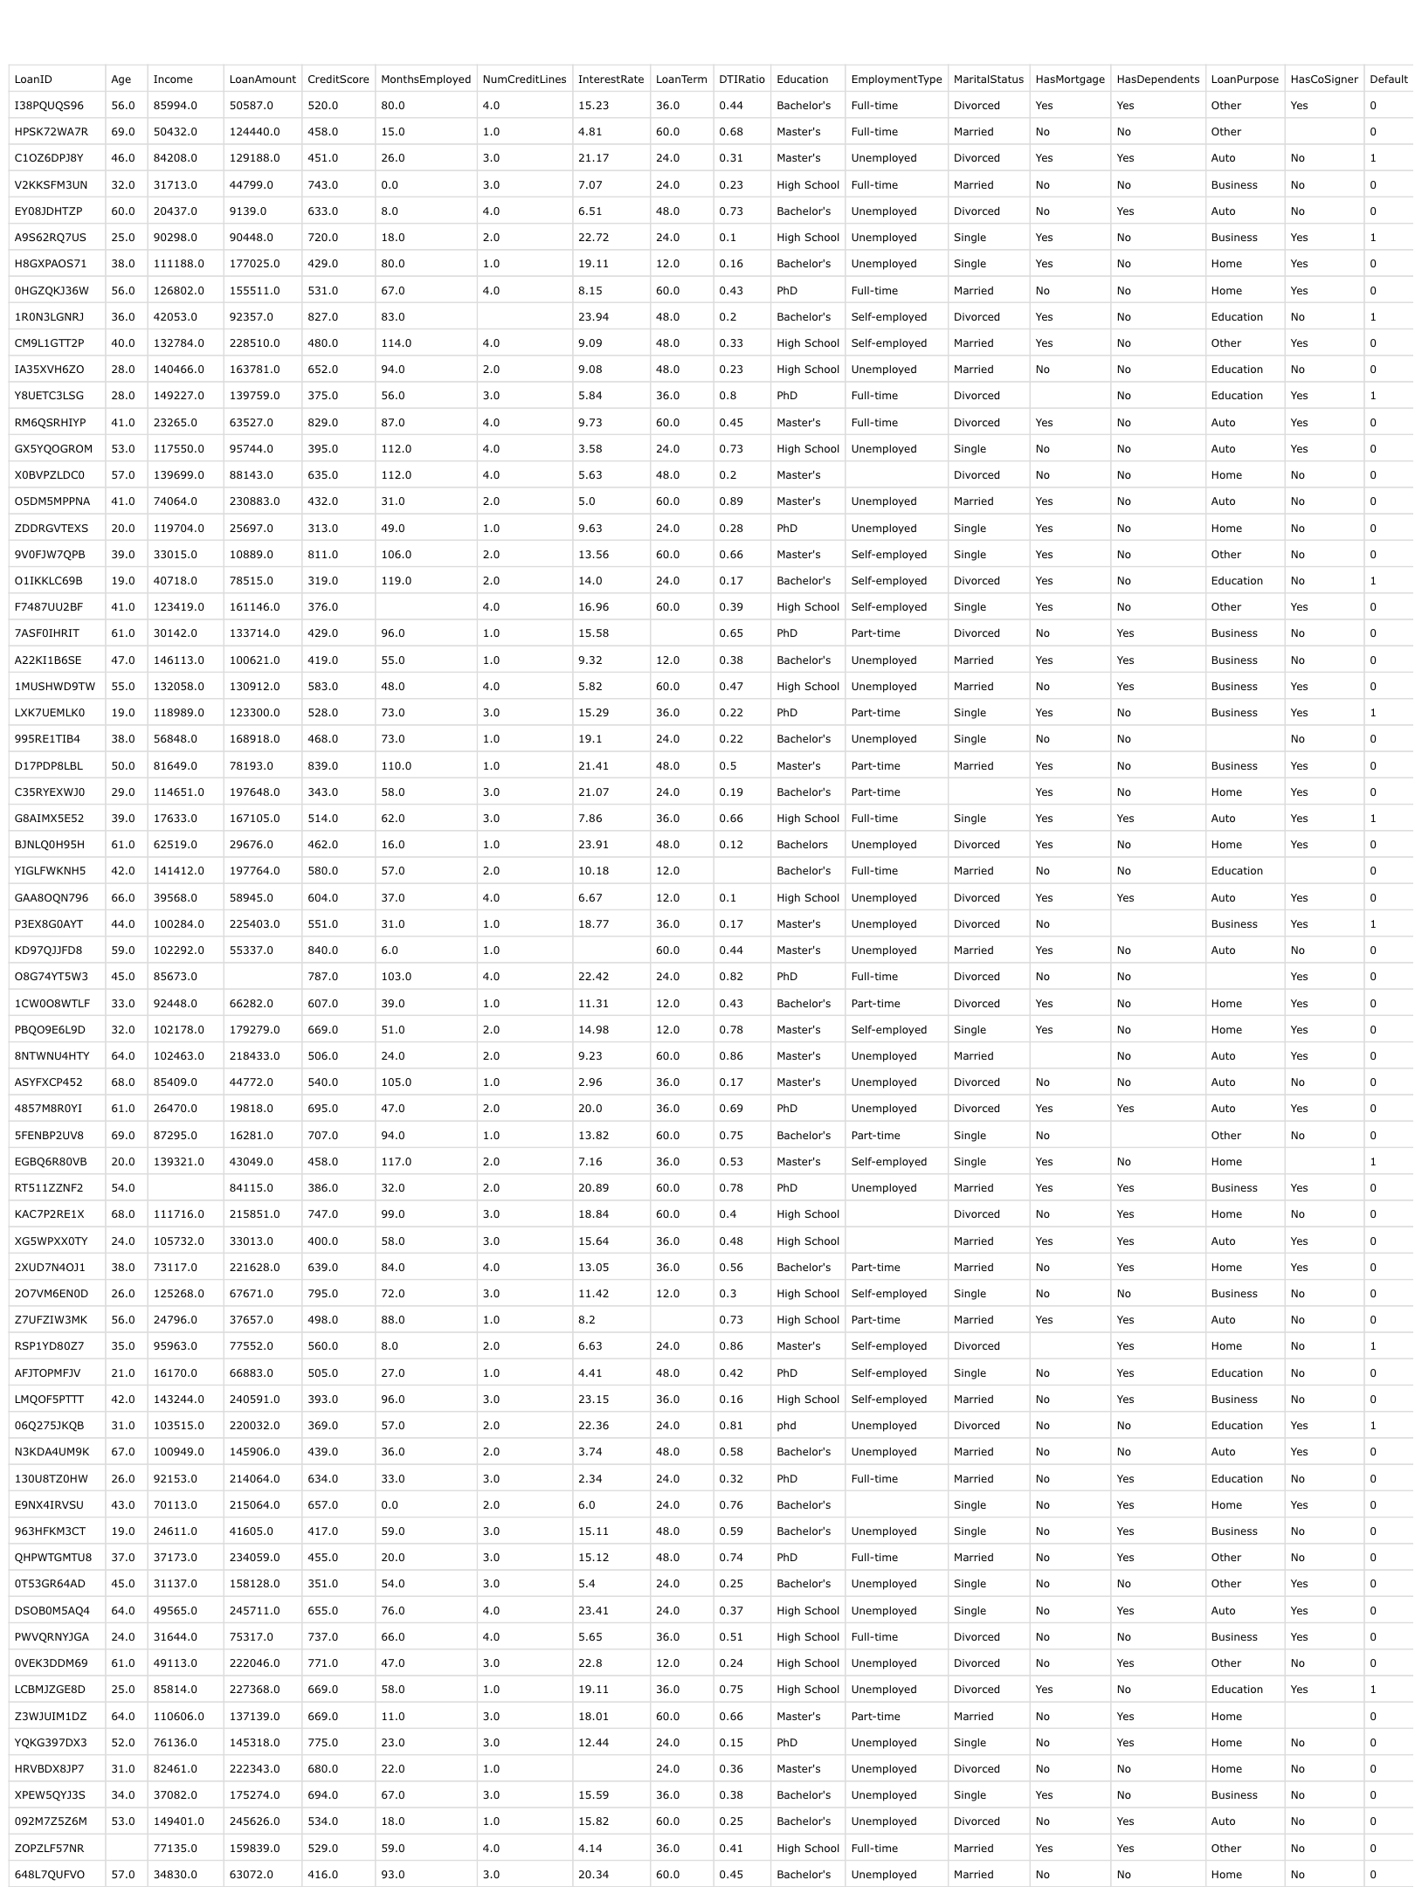
Fig 1: Sample dataset
1.2. Flow diagram
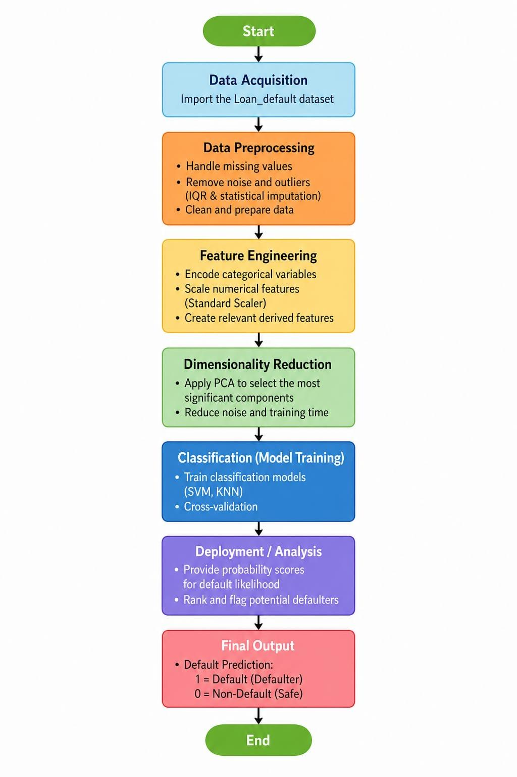
Fig 2: Flow diagram of the proposed system.

2. Modules for Project Implementation
2.1 Modules used
Pandas

Pandas acts as the backbone of the project’s data management. In this system, it is used to load the Loan_default.csv file into a DataFrame, allowing for easy manipulation of rows and columns. Beyond just reading data, it is used to perform feature selection and data cleaning, such as identifying null values and calculating statistical summaries like the mean or median of borrower incomes. It essentially transforms raw, messy banking data into a structured format ready for analysis.
Numpy
NumPy is used for the underlying mathematical computations that drive the machine learning models. While Pandas handles the tables, NumPy handles the multi-dimensional arrays and complex math, such as calculating distance metrics for the KNN algorithm. It is essential for performing element-wise operations on large datasets, ensuring that heavy calculations are performed with high speed and efficiency, which is critical when dealing with thousands of customer records.

Scikit-Learn (Preprocessing)

This module is responsible for "normalizing" the data so that the models can interpret it fairly. The StandardScaler is used to ensure that features with large ranges (like Income) don't overrule smaller numerical features during model training. It also includes LabelEncoder, which converts categorical text—such as "Full-time" or "Unemployed"—into numbers that the SVM and Random Forest algorithms can process. Without this, the models would be unable to mathematically compare different types of borrower information.

Imbalanced-Learn (SMOTE)

In credit risk datasets, "Defaulters" are typically a small percentage of the total data. If trained on this unbalanced data, a model will likely just learn to predict "Non-Default" for everyone. SMOTE (Synthetic Minority Over-sampling Technique) solves this by creating "synthetic" examples of defaulters. By balancing the dataset, the models learn the specific characteristics of high-risk borrowers more effectively, significantly improving the Recall metric of the system.

Matplotlib & Seaborn

These are the primary tools for Exploratory Data Analysis (EDA). Seaborn Heatmaps are used to visualize the correlation matrix, allowing the bank to see how strongly a "Credit Score" relates to a "Default." Histograms display the distribution of loan amounts, while Boxplots help identify "Outliers"—such as borrowers with impossibly high incomes—which might indicate data errors. These visualizations are crucial for communicating findings to stakeholders.

.

2.2. Platform used

Jupyter Notebook

• Interactive Development: Jupyter Notebook provided an interactive environment that allowed for executing credit risk analysis code in "cells," making it easy to test individual preprocessing steps like SMOTE or scaling without rerunning the entire script.

• Integrated Data Visualization: It enabled the direct display of Seaborn heatmaps and Matplotlib histograms within the workspace, which was essential for Exploratory Data Analysis (EDA) to visualize correlations between credit scores and defaults.

• Literate Programming: The platform allowed for the combination of executable Python code with Markdown documentation, enabling the team to explain the logic behind model choices (like SVM vs. KNN) alongside the actual implementation.

• Sequential Data Workflow: Its linear structure perfectly matches the machine learning pipeline of this project—moving systematically from data loading and cleaning to dimensionality reduction (PCA) and final model evaluation.

• Debugging and Optimization: Jupyter’s ability to maintain the state of variables in memory allowed for fine-tuning Random Forest hyperparameters and re-evaluating metrics like "Recall" instantly, ensuring the most accurate risk assessment results.
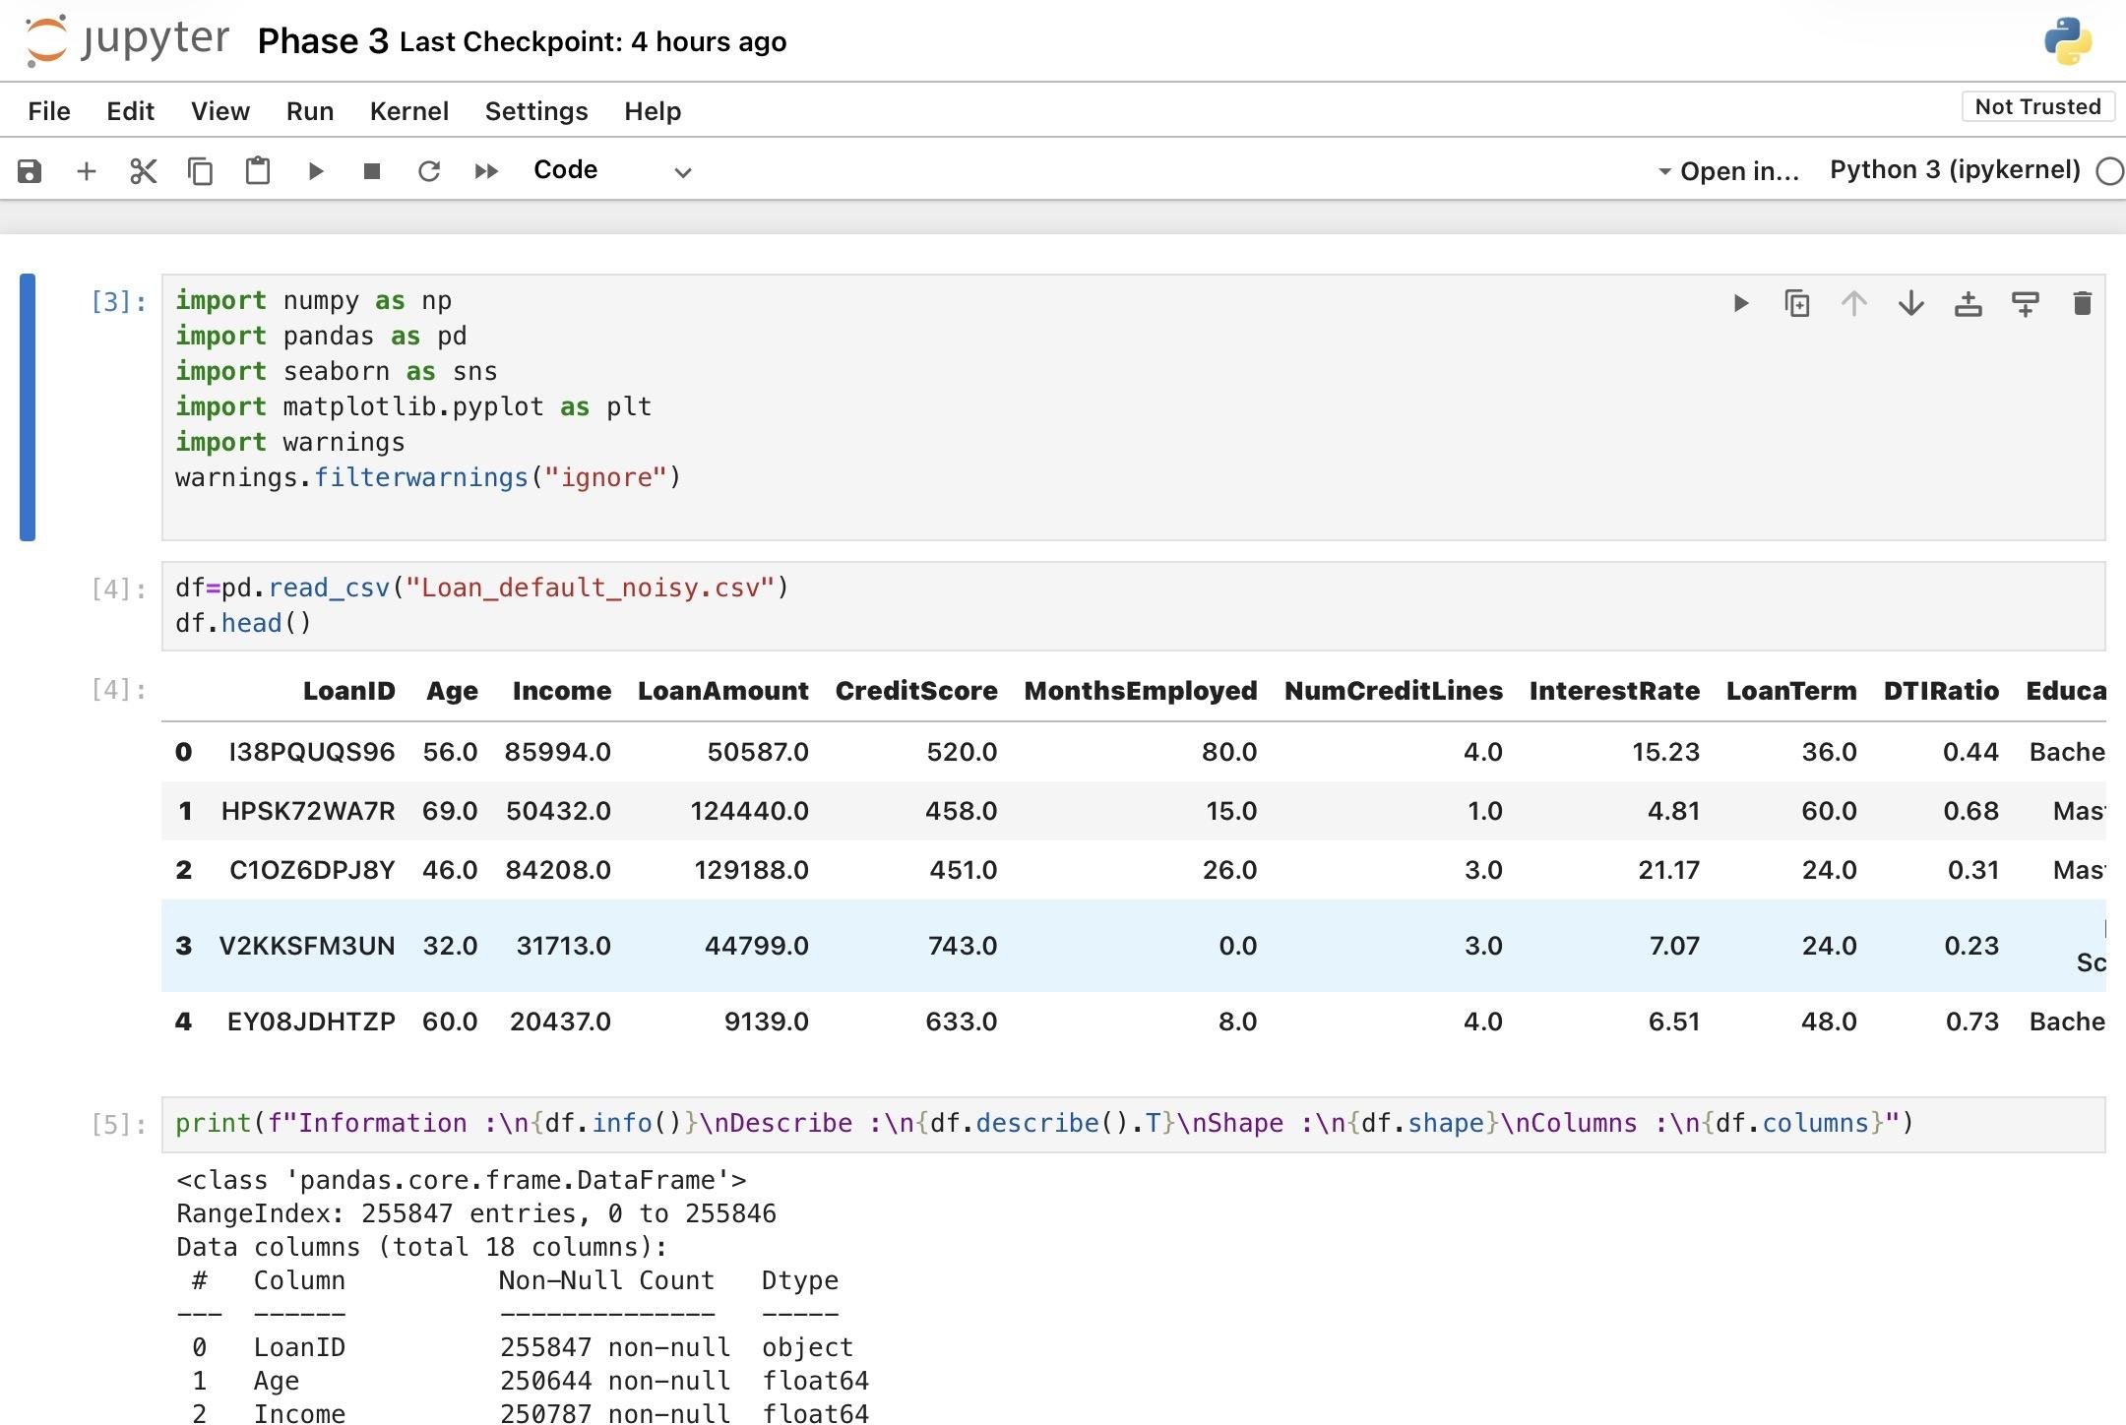
Fig 3: Jupyter Notebook

3. Machine learning Models Used

Support Vector Machines (SVM)
SVM is used to find the optimal hyperplane that maximizes the margin between classes (Default vs. Non-Default). We utilize various kernels such as Linear, Poly, and RBF to handle non-linear relationships in the banking data.

K-Nearest Neighbors (KNN)
KNN classifies a borrower based on the characteristics of the 'K' most similar historical customers. It is effective for identifying patterns in borrower behavior without assuming a specific data distribution.
Principal Component Analysis (PCA)
An unsupervised model used to compress the feature space. It identifies the principal components that explain the maximum variance in the banking dataset, helping the classifiers run faster and potentially avoid overfitting.
Logistic Regression (Planned/Baseline)
While the core analysis focuses on SVM and KNN, the reports and synopsis mention Logistic Regression as a baseline model. This is a statistical model used for binary classification. It estimates the probability of an event (default) occurring based on input features using a logistic function.
Random Forest Classifier
Random Forest is an "Ensemble Learning" method that operates by constructing a multitude of Decision Trees during training. It makes a final prediction by taking the majority vote (for classification) from all the individual trees.

4. Evaluation Metrics Used
- Accuracy: Percentage of total correct predictions.

- Recall: Critical in banking; it measures the ability to identify all actual defaulters to minimize losses.

- F1-Score: Provides a balance between Precision and Recall, ensuring the model isn't biased.

- Confusion Matrix: Visualizes the performance of the classification algorithm. A confusion matrix shows:
- True Positive (TP)
- True Negative (TN)
- False Positive (FP)
- False Negative (FN)
Importance:
Helps analyze model performance
Identifies misclassification

- Heatmap (Confusion Matrix Visualization): A heatmap visually represents the confusion matrix using colors.
Advantages:
Easy interpretation
Detects errors quickly

5. Results and Visualizations
Initial Exploratory Data Analysis (EDA) shows that interest rates and credit scores are the most significant indicators of default. Heatmaps generated during the analysis helped identify multi-collinearity between features.

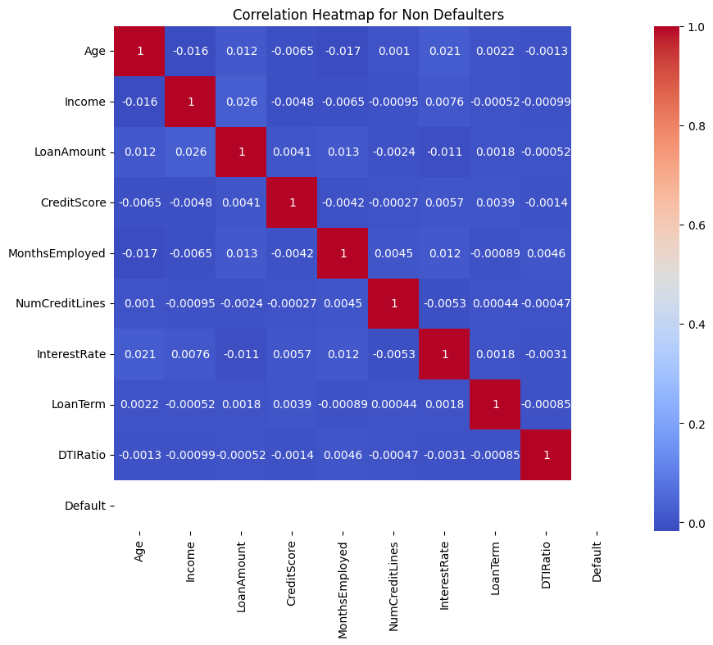
Fig 4: Figure showing Heatmap of the Feature correlation
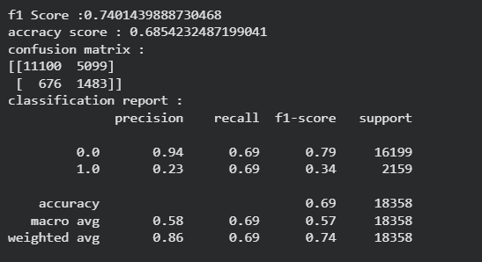
Fig 5: Figure showing linear SVC report
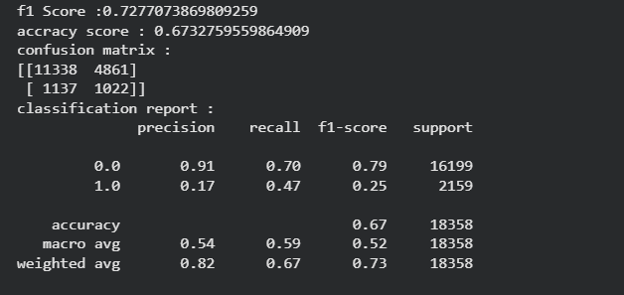
Fig 6: Figure showing knn report

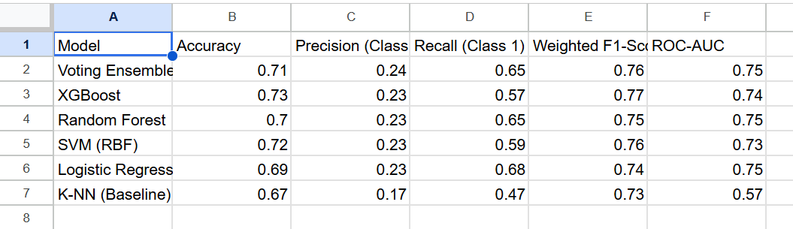
Fig 7: Figure showing information about all models used

6. Conclusion & Future Scope

• Conclusion: The project successfully automated credit risk assessment using ensemble learning. By balancing the data with SMOTE and using a Voting Classifier, we created a system that minimizes financial loss (NPAs) through objective, data-driven lending decisions.

• Future Scope: Future enhancements include deploying the model as a web application using Flask, integrating real-time transaction monitoring, and using Explainable AI to provide transparent reasons for loan rejections.

7. References

Books:
- 1. Hands-On Machine Learning with Scikit-Learn, Keras, and TensorFlow – Aurélien Géron
- 2. Pattern Recognition and Machine Learning – Christopher Bishop

Online Resources:
- 1. Scikit-Learn Documentation: https://scikit-learn.org/
- 2. Pandas Official Guide: https://pandas.pydata.org/

